

Dear Carrier/Freight Broker,

The culture of SMM & SRS is built around its core values of Safety, Integrity, Respect, Transparency, Excellence, and Social Responsibility. These core values determine who SMM & SRS are and are the foundation of everything SMM & SRS do; they set the standard for the way SMM & SRS interact with its employees, customers, communities and all stakeholders, including its vendors & carriers.

The first of those core values is Safety.  SMM & SRS strive for a “ZERO-harm workplace.”  Below is a link to an on-line *‘Visiting Driver Site Safety Orientation’* video that we ask all drivers to view before entering one of our facilities.

* <https://simsdrivers.mtssafety.com/>

In addition, we require ALL personnel on our sites **must** wear the PPE (Personal Protection Equipment) which is listed below. This is for their own safety as well as others.

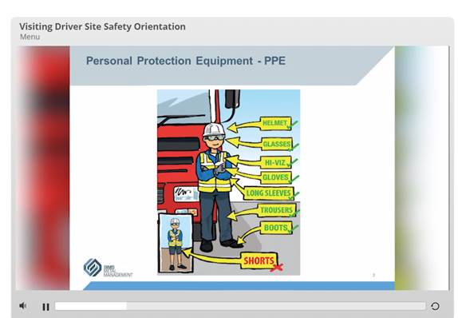

Additional Requirements may be:

* SMM/SRS require drop trailers in docks to use wheel chocks & stands
* A number of SMM/SRS facilities have ‘Dock Locks’ and/or they may also use ‘Air Brake Locks’
* Drivers may be asked to lock their keys in a secure lock box until the trailer is completely loaded or unloaded